Kubernetes Lab Marcel Zama

Starting a Kubernetes Minikube:

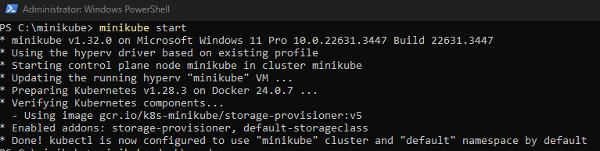

Opening the Kubernetes dashboard:

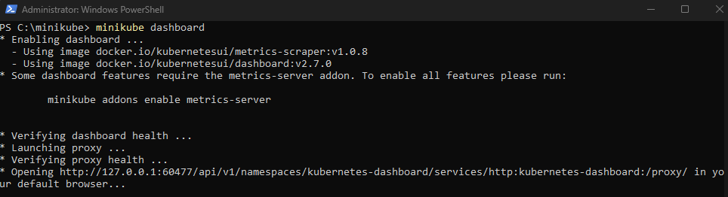

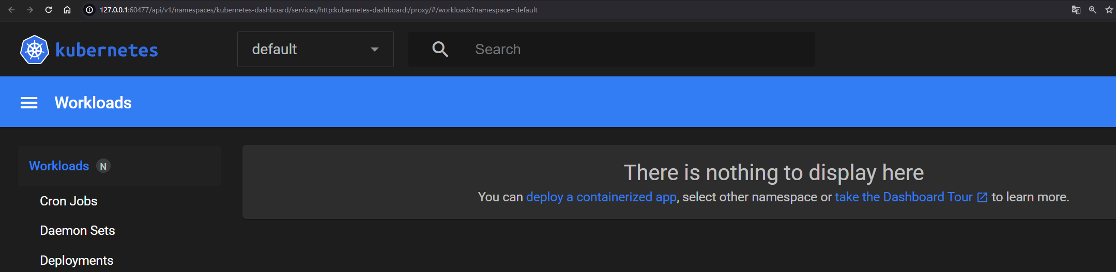

Deploying an App

Creating a Deployment:



Viewing the Deployment:

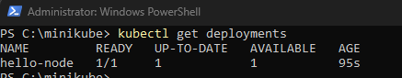

Viewing the Pod:

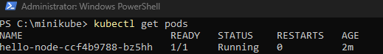

Viewing application logs for a container in a pod:

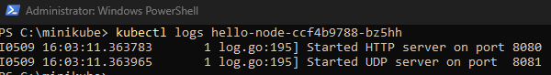

Updated Kubernetes Dashboard: 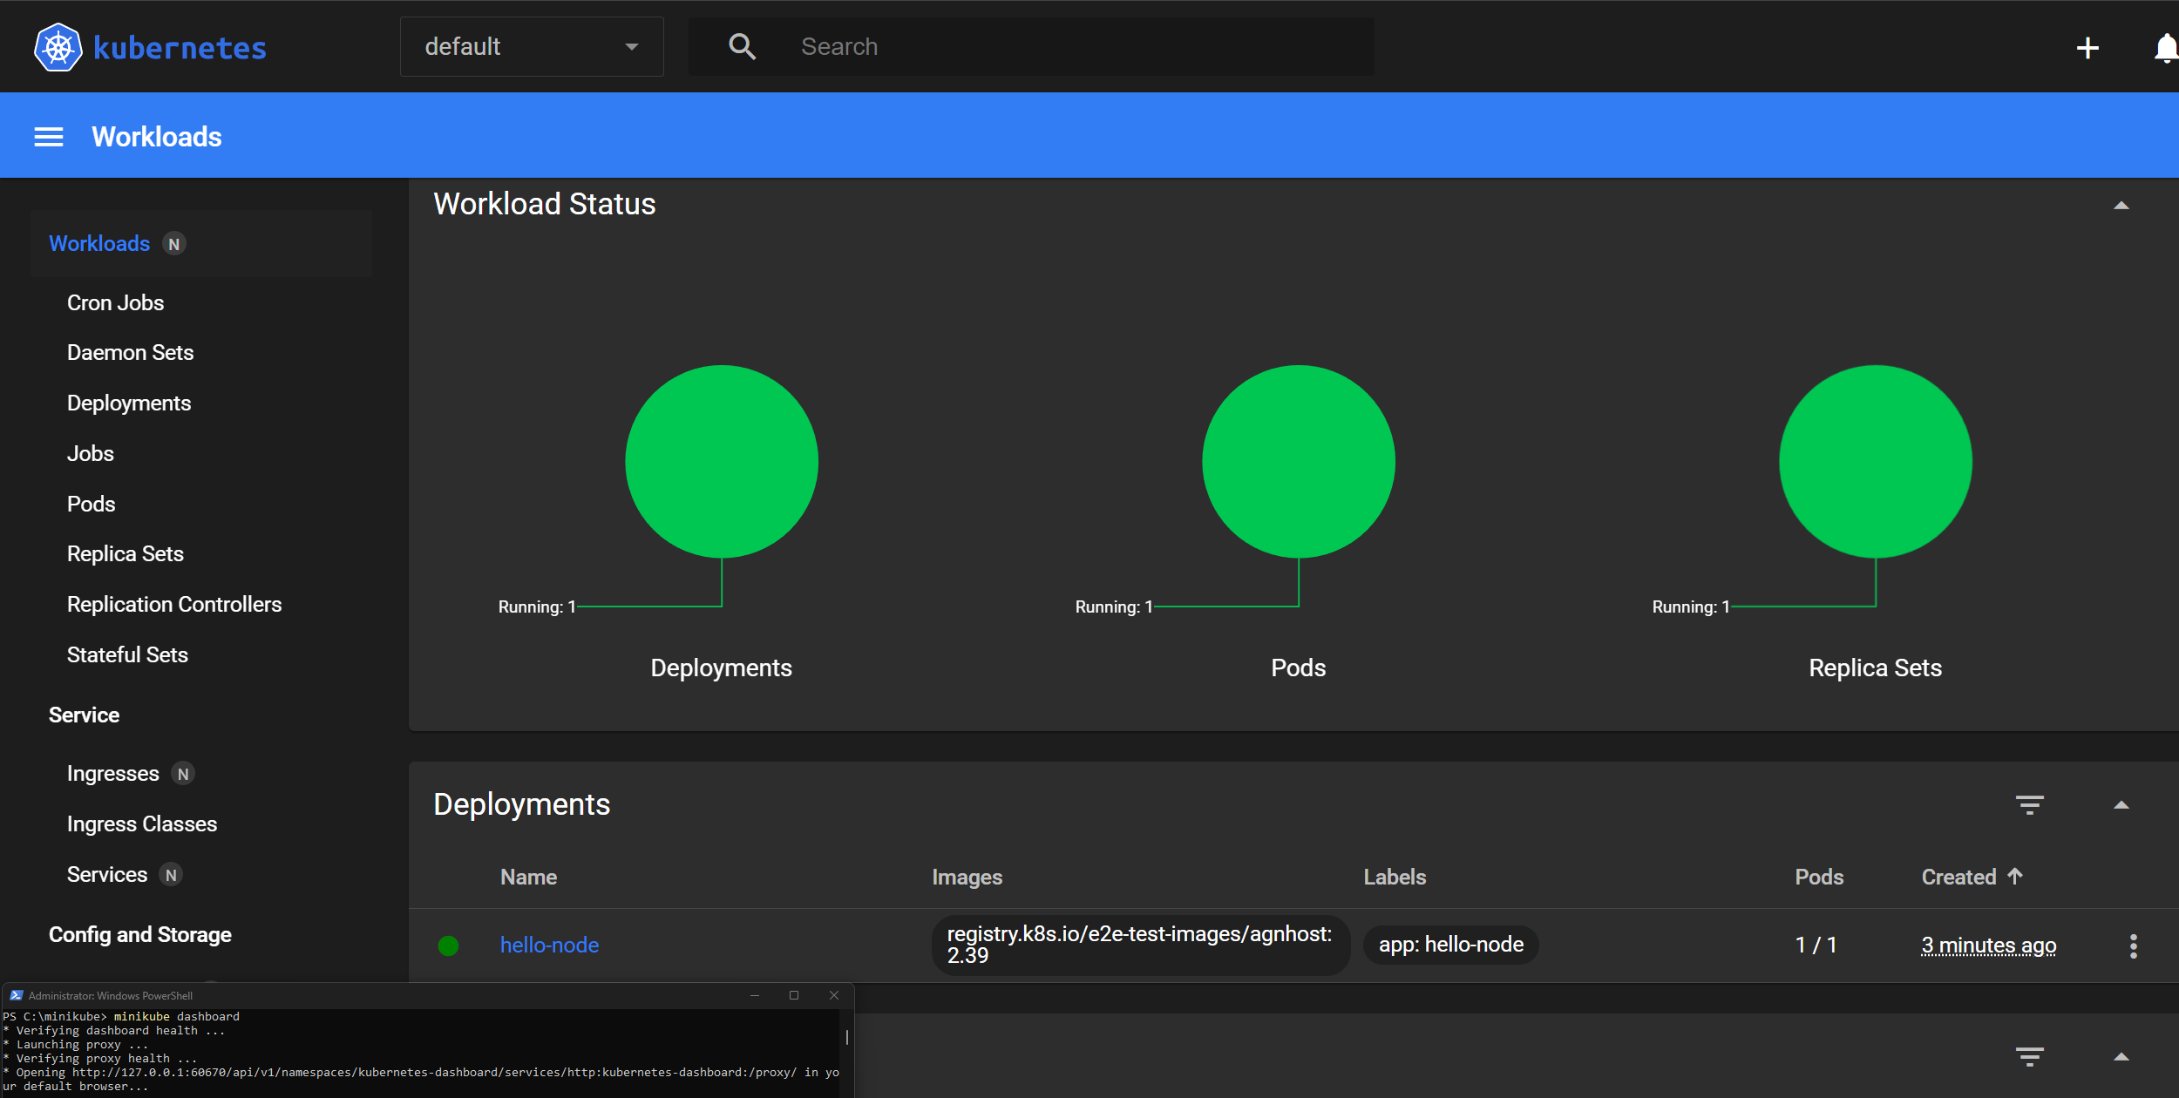

Deploying Kubernetes bootcamp app image:



Listing updated deployments:

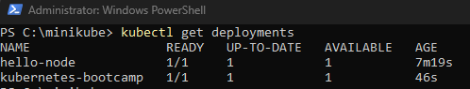

Checking Dashboard For new Pod:

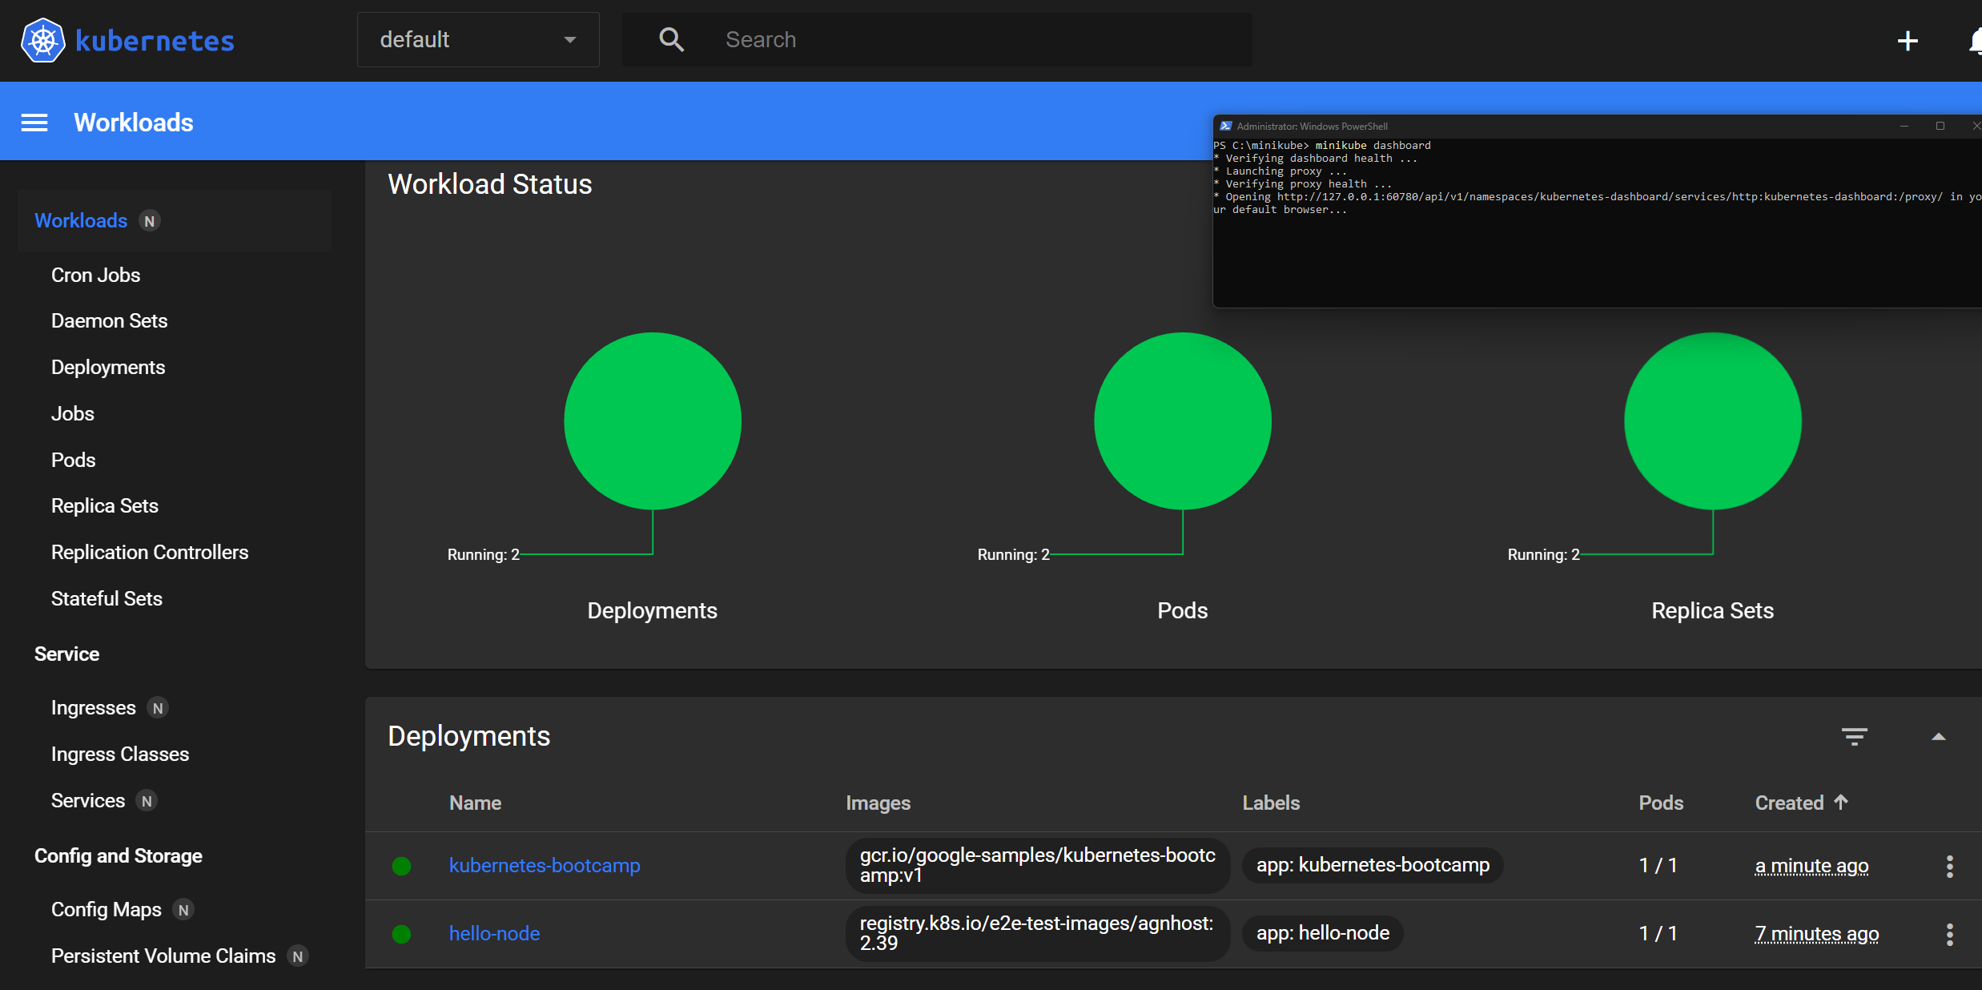

Checking APIs hosted through the proxy endpoint: 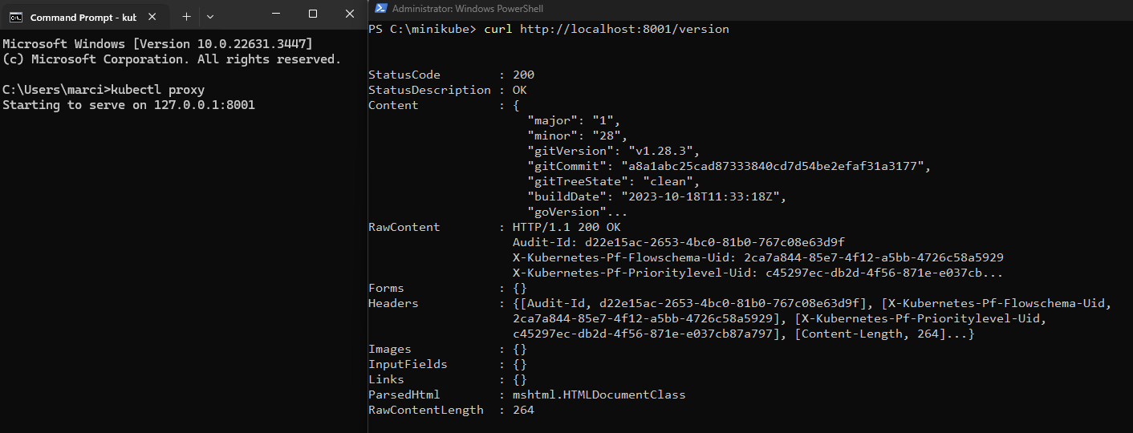

**Viewing Pods and Nodes:**

Check application configuration:

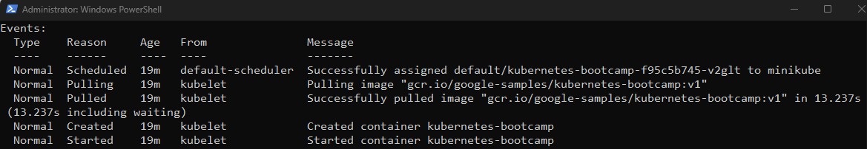

Executing commands on the container

Listing Available Commands:

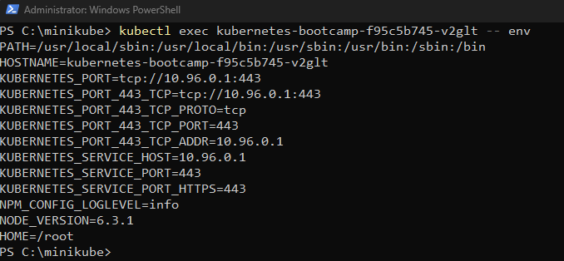

Starting Bash Session in Pod’s container and opening ‘server.js’:

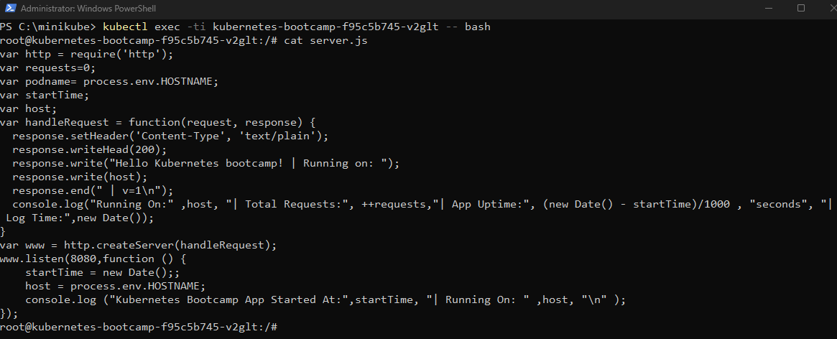

Verifying that the application is running:

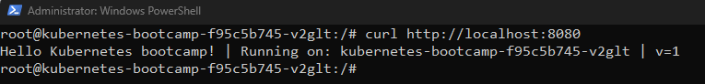

Using a Service to Expose Your App:

Creating a New Service:

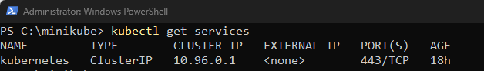

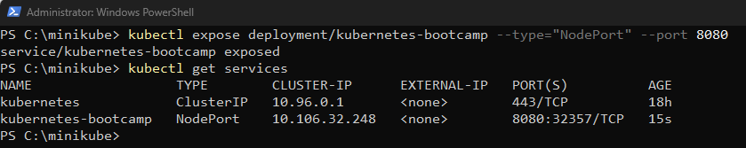

Finding the externally opened port on the service:

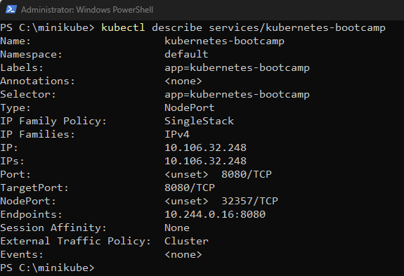

Creating a NODE_PORT environment variable:

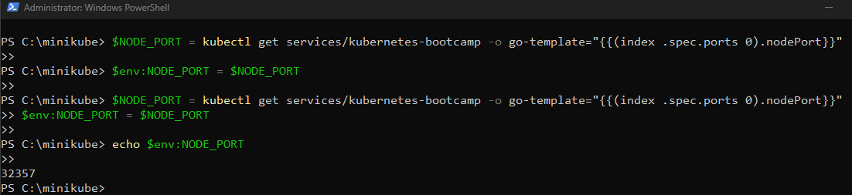

Testing that the app is exposed outside the cluster using curl:

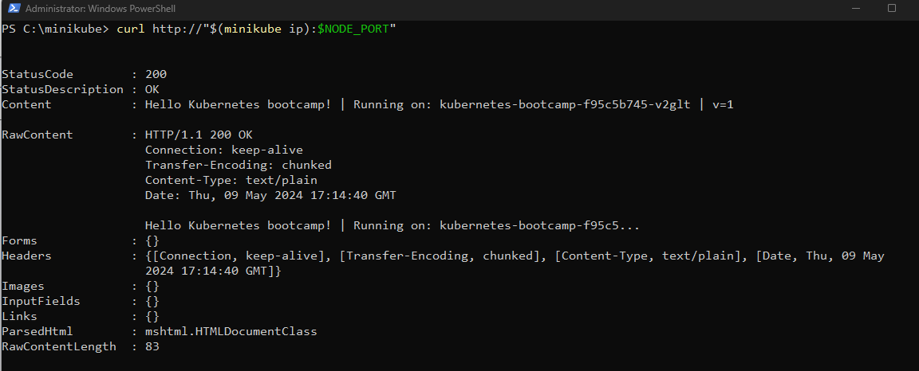

Applying a new label:

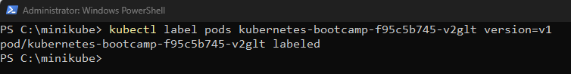

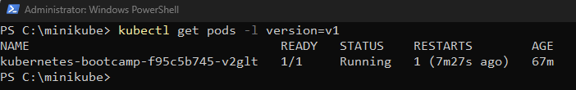

Deleting a service:

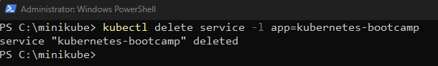

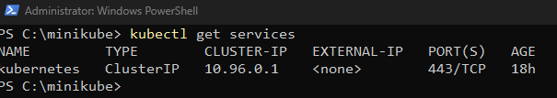

Confirming that the route is not exposed anymore:

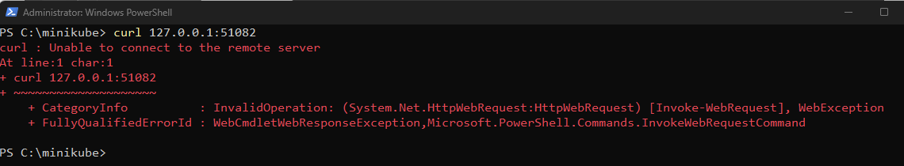

Running Multiple Instances of Your App:

Viewing the ReplicaSet created by the deployment:

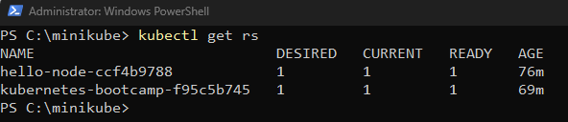

Scaling the deployment to 4 replicas:

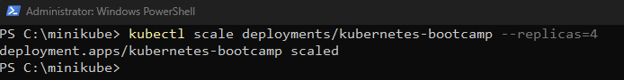

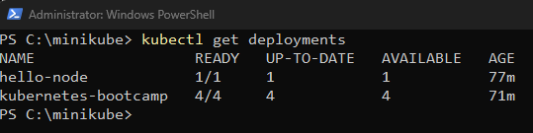Checking that the Service is load-balancing the traffic: 

Scaling Down the application:

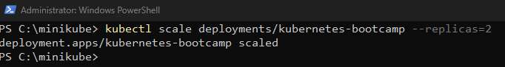

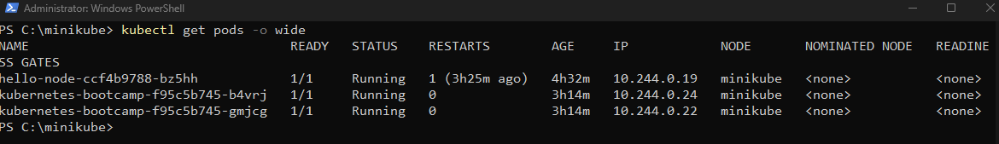

Performing a Rolling Update:

Updating the version of the app to version 2:



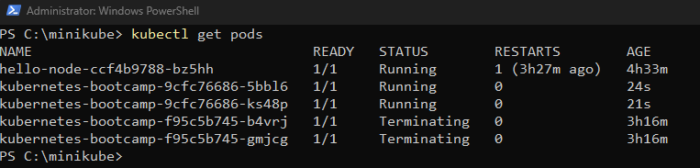

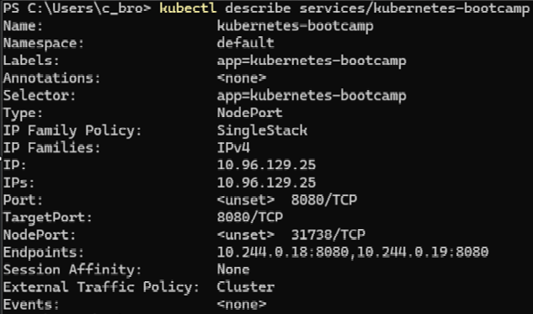

Running the roll out status command:

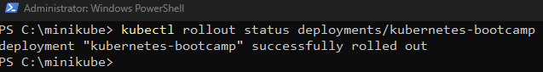

Cleaning up the local cluster:

